MOOD Metrics



Ricardo Pereira 57912

MOOD Metrics

This metrics are used to measure the quality of some characteristics of OO(object oriented) programs, and this are: AHF, AIF, CF, MHF, MIF and PF.  
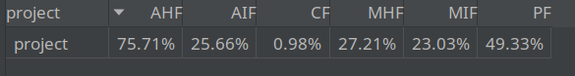

* **AHF(Atribute Hiding Factor)**: All attributes should be hidden, only being accessed by the corresponding class methods. Sum of all hidden attributes (in all classes) divided by the sum of visible attributes and hidden attributes(in all classes). Should be 100%. In these case it is 75.71%.
* **AIF(Attribute Inheritance Factor)**: Should be used but not too extensively. Sum of the inherited attributes divided by the sum of defined attributes and inherited attributes. In this case it was 25.66%.
* **CF(Coupling Factor)**: Measure of coupling between classes. It is desirable that the classes communicate with as few other classes as possible, so the lower the better. In this project it was 0.98%.

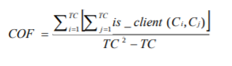

TC = Total number of Classes.

is_client(Cc, Cs) = if((Cc => Cs) and (Cc != Cs)) return 1 else return 0

* **MHF(Method Hiding Factor)**: All methods should be hidden, only being accessed by the corresponding classes. Sum of all hidden methods (in all classes) divided by the sum of visible methods and hidden methods(in all classes)(should be 100%). In these case it is 27.21%.
* **MIF(Method Inheritance Factor)**: Should be used but not too extensively. Sum of the inherited methods divided by the sum of defined methods and inherited methods. In this case it was 23.03%.
* **PF(Polymorphism Factor)**: Represents the number of possible different polymorphic situations. Should be used but 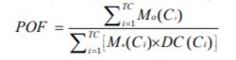not too extensively. In this project it was 49.33%.

Mo = methods that override other methods

Mn = new methods

DC = classes that derivate from another class

TC = total number of classes